**Coffees with Espresso**

Source: <https://www.gocoffeego.com/professor-peaberry/brewing-tips/espresso-drinks>

## Café Americano

## Image result for cafe americano

This is essentially a watered-down shot of espresso with the resulting flavor arriving very close to simple, brewed coffee. One espresso shot (1 ounce) with 6-8 ounces of hot water.

-hot water

-single shot espresso

**Espresso Macchiato**

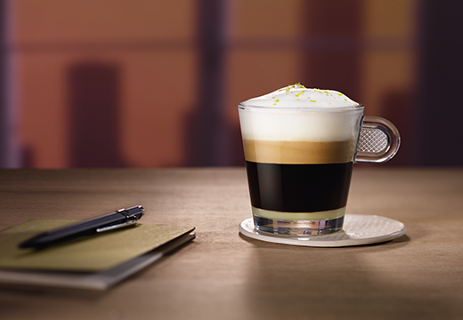

Despite Starbucks’ popularization of the term Macchiato as a brand name, this is a very simple drink devoid of the flavored caramel and chocolate treatment better suited to an ice-cream parlor. It is simply a shot of espresso with a layer of foamed milk

-Milk foam

-Single shot Espresso

**Cappuccino**

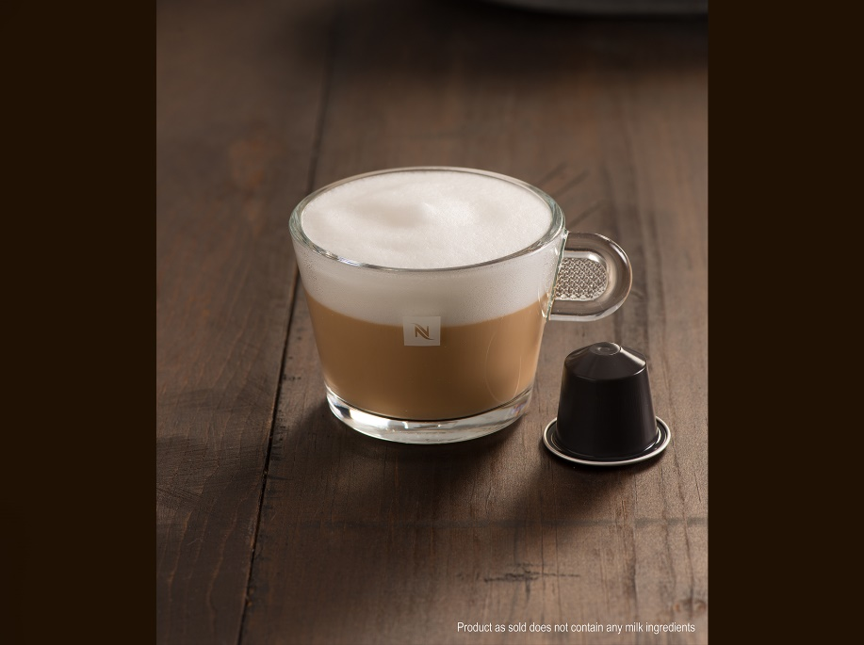

Another drink warped by misconceptions! Cappuccino, named for its similarity in color to the robes of Capuchin monks, is simply a shot of espresso with steamed, wet milk, not necessarily slathered with a frothy, dry foam.

-steamed milk

-single shot espresso

## Café Latte

## Image result for cafe latte

This is very popular drink in America probably due to its sweet, mellow flavor. One shot of espresso is mixed with 6 to 8 ounces of steamed milk, then topped with foam - if you prefer. Without the foam it’s officially known as a Flat White. Since it’s hard to find a latte in the super-sized United States smaller than 12 ounces, a double shot of espresso is common. If you prefer greater amperage via caffeine, up the number of shots!

With a few minor variations, this also goes by the name Café con Leche or Café Au Lait, depending on whether your coffee spirit is channeling Spanish or French.

-milk foam

-steamed milk

-single shot espresso

**Iced Coffee**

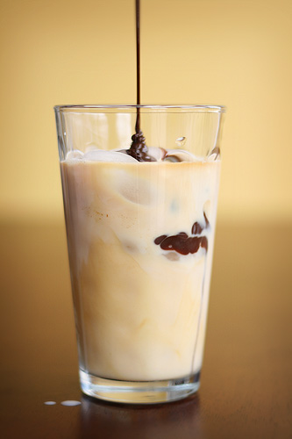

Like Sasquatch and Yeti, the perfect iced coffee is very elusive. Coffee with ice cubes makes for watery, cold coffee. Begin with strong coffee - stronger than you would normally brew hot. Try bolder tasting, dark roasts. Brew it strong. You can double brew by pouring hot coffee back onto fresh grinds - like pouring the coffee back into the coffee maker and brewing again. Add sugar or spices like cardamom before chilling so they dissolve thoroughly. You can add ice then, but it’s best to chill in the refrigerator for a few hours or even overnight so the ice doesn’t melt so fast.

Once chilled, pour over ice and mix with whole milk or, even better, half and half, to taste. Favorite syrups, like chocolate for an iced mocha, can go in to the mix now. Just be sure to use all of that energy or an afternoon workout. -Chocolate syrup

-whole milk

-single shot chilled espresso

**FOODS (Sweets, Cakes, Pastas)**

**BLUEBERRY CHEESECAKE**

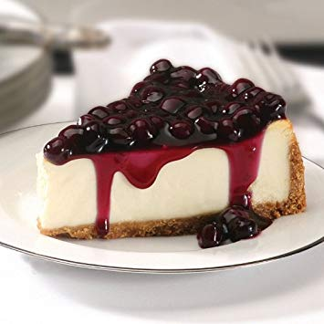**Blueberry Cheesecake** is a sweet dessert consisting of one or more layers. The main, and thickest layer, consists of a mixture of soft, fresh cheese (typically cream cheese or ricotta), eggs, and sugar. If there is a bottom layer, it often consists of a crust or base made from crushed cookies (or digestive biscuits), graham crackers, pastry, or sometimes sponge cake.[1] It may be baked or unbaked (usually refrigerated)

#### Ingredients

* Cheese
* Graham Cracker
* Pastry
* Sugar

**SPAGHETTI WITH MEATBALLS**

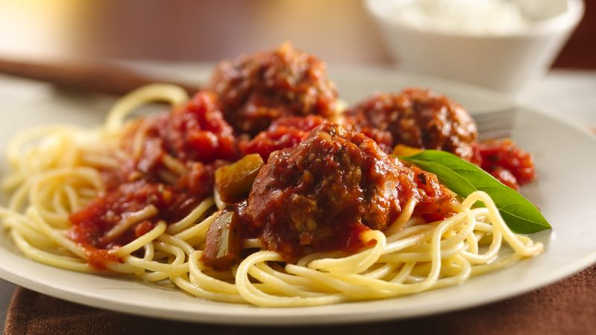  
It is widely believed that **spaghetti and meatballs** was an innovation of early 20th-century Italian immigrants in New York City. The National Pasta Association (originally named the National Macaroni Manufacturers Association) is said to be the first organization to publish a recipe for it, in the 1920s.

#### Ingredients

* Spaghetti
* Tomato Sauce
* Meatballs

**CHOCOLATE BANANA CAKE**

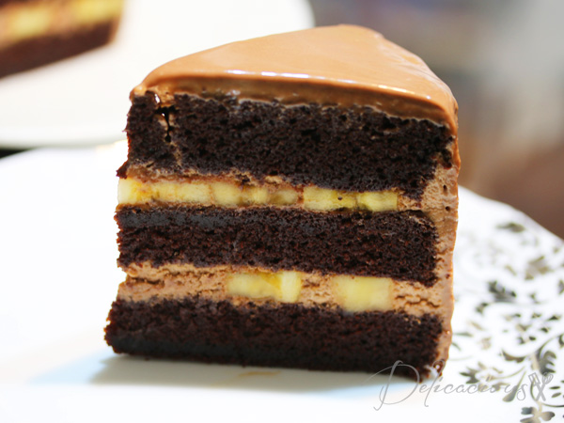

This **chocolate banana cake** is a layer **cake** made extra moist and flavorful with mashed ripe **bananas** in the batter. Frost this delicious **chocolate banana cake** with **chocolate** frosting or a cream cheese frosting.

Ingredients

* 1 cup cake flour
* 1 cup plain flour
* ¾ cup dutch-processed cocoa powder
* 1 tsp baking powder
* 2 tsp baking soda

**GLAZED DONUT**

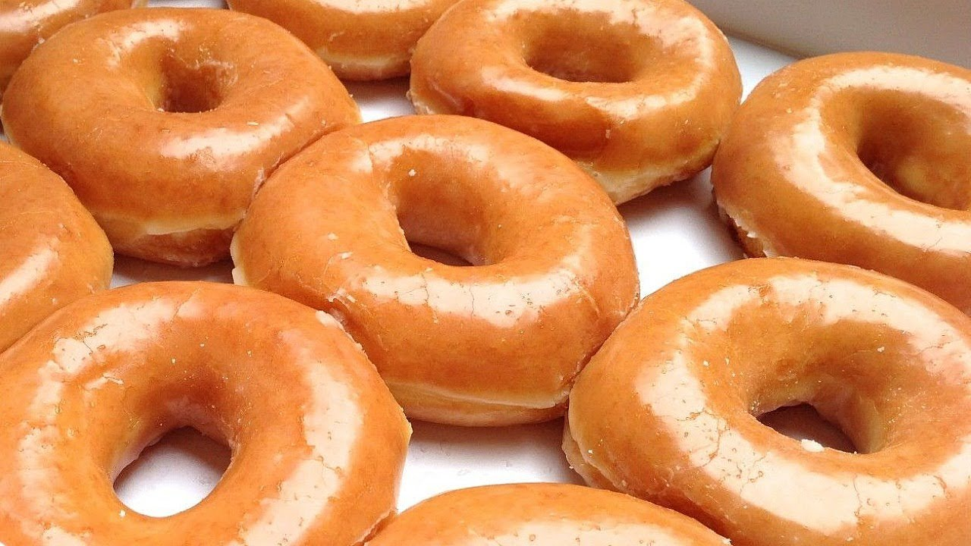

If you haven’t had a glazed donut before, bless your heart, and get your mixing bowl out. You MUST try them — they’re like heaven on earth! They’re little airy fried pastries shaped like a circle with a hole in the middle, and they’re light, fluffy, and covered with a sugar icing called glaze.

* 1 tablespoon plus 1 teaspoon active dry yeast.
* 1 cup whole milk, heated to 110°F.
* 2 to 2 1/2 cups (320 to 400 grams) bread **flour**.
* 1 teaspoon pure vanilla extract.
* 3 large egg yolks.
* 2 tablespoons (30 grams) superfine sugar.
* 1/2 teaspoon table salt.
* 4 tablespoons (1/2 stick or 2 ounces) unsalted butter, softened at room temperature and cut into cubes
* Vegetable oil for frying
* [Basic Sugar Glaze](https://www.epicurious.com/recipes/food/views/51157020)